RESOLUTION NO.__________

RE: CERTIFICATE OF APPROPRIATENESS UNDER THE
PROVISIONS OF THE ACT OF THE PENNSYLVANIA
LEGISLATURE 1961, JUNE 13, P.L. 282 (53
SECTION 8004) AND BETHLEHEM ORDINANCE NO.
3952 AS AMENDED.

WHEREAS, it is proposed to paint the exterior of the home at
72 E. Market St.

NOW, THEREFORE, BE IT RESOLVED by the Council of the City of Bethlehem that a Certificate of Appropriateness is hereby granted for the proposal.

Sponsored by: (s)

(s)

ADOPTED BY COUNCIL THIS DAY OF

(s)
President of Council

ATTEST:

(s)
City Clerk

HISTORICAL & ARCHITECTURAL REVIEW BOARD

The applicant is proposing to paint the exterior of the home at
72 E. Market St.
APPLICATION #3:

Rodman & Lori Young
72 E. Market St.
Bethlehem, PA 18018

OWNER:

__________________________________________________________________________

The Board upon motion by Gen Marcon and seconded by Beth Starbuck adopted the proposal that City Council issue a Certificate of Appropriateness for the following:

- Paint the exterior of the home with the following color scheme:
Stucco: HC-176 BJM Annapolis Gray
Trim: SW-2840 Hammered Silver
Shutter: SW-7082 Stunning Shade
Front Door/Garage Doors: SW-7048 Urban Bronze
Railing: Dark Bronze

2. Shutters to be added on east side and above the sunroom.

3. Plaque above triple window to be tone on tone.

4. Metal roof to be painted same color as Terra Cotta roof.

5. Metal trim/coping to be same color as trim. In addition, white mullions/muntins
are also being painted the same color as the trim.

6. The motion was unanimously approved.
__________________________________________________________________________

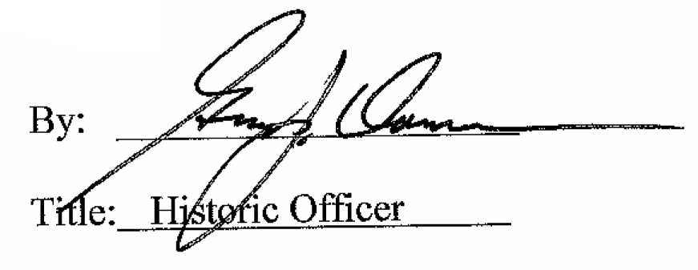

Date of Meeting: April 5, 2017

